Questions and Exercises to work out and turn in:

Grading Guidelines:

A right answer will get full credit when:

1. It is right (worth 25%)
2. It is right **AND** neatly presented making it easy and pleasant to read. (worth an **extra** 15%)
3. There is an **obvious and clear link[1]** between 1) the information provided in the exercise and in class and 2) the final answer. A clear link is built by properly writing, justifying, and documenting an answer (worth an **extra** 60%).
4. Calculation mistakes will be minimally penalized (2 to 5% of full credit) while errors on units will be more heavily penalized.

**Late Submission** : as specified in the syllabus. Days counting starts one minute after the deadline.

**Check Your Submission:**  after submitting, download your submission to check whether it is the right version and it is complete.

You are welcome/encouraged to discuss exercises with other students or the instructor. But, ultimately, **personal** writing is expected.

* USE THIS FILE AS THE STARTING DOCUMENT YOU WILL TURN IN. **KEEP IN THE QUESTIONS** AND INSERT YOUR ANSWERS.
* IF USING HAND WRITING (STRONGLY DISCOURAGED), REWRITE THE QUESTIONS.
* FAILING TO FOLLOW TURN IN DIRECTIONS /GUIDELINES WILL COST A 30% PENALTY.

Objectives of this assignment:

* to explore the relationship between switches processing time and propagation time

What you need to do:

Answer the questions and/or solve the exercises described below.

Exercise 1 (100 points)

*This exercise explores of the impact of the switching time (time spent on routers, switches or other intermediary networking devices) and the propagation time (impacted by distance).*

*A factor in the delay of a store-and-forward packet-switching system is the switch time, -namely the time it takes to store and forward a packet through a switch (router (L3 switch) or L2 switch). The objective of this exercise is to investigate the impact of the switch time on the overall delivery delay of a packet. The switch time is about 5 se per device: we assume (oversimplification) that each device adds this switching time to the packet delay in order to process (routing...) the packet. Consider a packet P sent from Auburn University (AU) to Stanford University (about 4,000 kms from Auburn) over a copper line. Assume the propagation speed in copper to be 2/3 the speed of light.*

1. (32 points) What is the propagation time from the packet P to reach the destination? Ping *www.stanford.edu* Insert here a screenshot of your ping collecting at least 15 ping packets. The ping must be executed on some Unix tux machine on the Engineering network. Your screenshot should look like this template screenshot (we should see the username, the date, the commands typed, and the results): Failing to post the screenshot or not providing all the required information will result in a 50 points penalty. Providing a screenshot of this task on your local machine will result in a 50 points penalty.

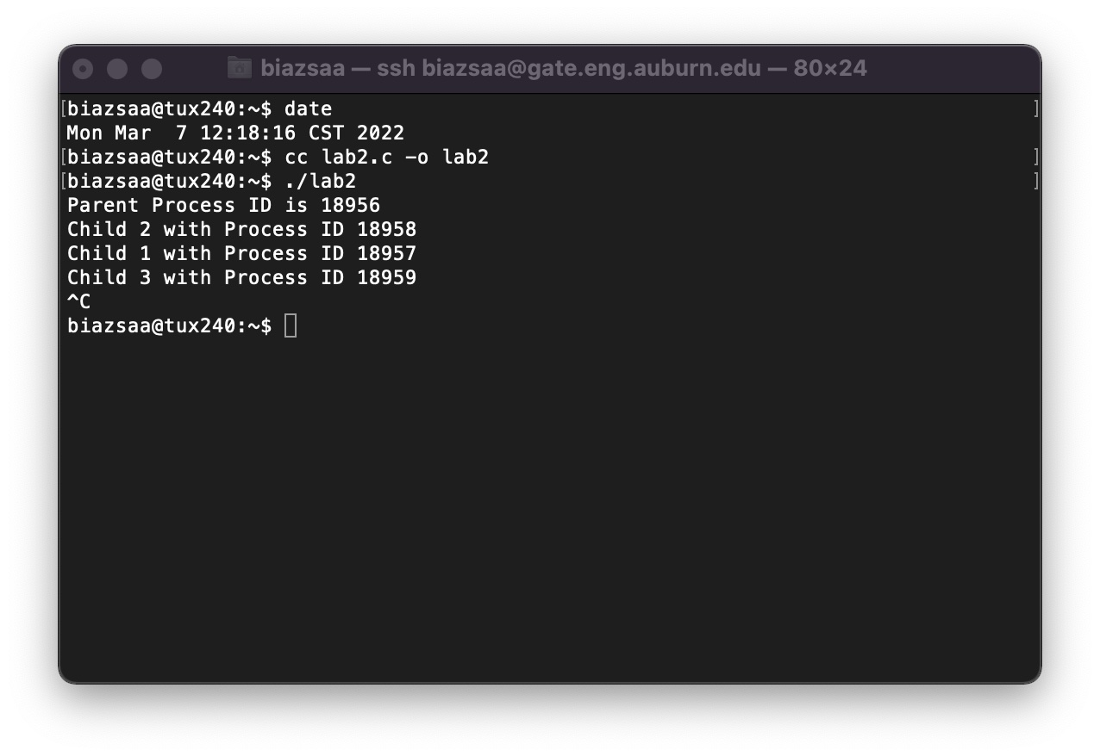

Screenshot

Report here the minimum, average, and maximum round trip time collected using Ping. Recall that the one way transit can be estimated as half the round trip time. Check/discuss whether your calculations (to determine the one way propagation time from source to destination) somewhat matches the ping measurements. If the calculations do not match the ping measurement, propose possible explanations.

I used the ping with 20 sequences to [www.stanford.edu](http://www.stanford.edu). The minimum round-trip time was 19.050 milliseconds. The average round-trip time was 19.192 milliseconds. The maximum round-time was 20.005 milliseconds. The one-way transit time is the average round-time time divided by 2 *1000 milliseconds. The propagation time from Auburn to Stanford University would approximately be 9596 milliseconds. So the ping measurements do in fact match somewhat the propagation time.

1. (16 points) Provide the approximate number of switches (routers) between a computer at Auburn University and a computer at the destination. Provide the answer and do not forget to write how you found the answer. Use the command traceroute on some Unix Tux machine. Let us know if you encounter difficulties.). Note that these commands do not reveal L2-switches. Provide a screenshot of the traceroute. Your screenshot should look like the template screenshot above (we should see the username, the date, the commands typed, and the results): Failing to post the screenshot or not providing all the required information will result in a 50 points penalty. Providing a screenshot of this task on your local machine will result in a 50 points penalty. A screenshot of a computer

   Description automatically generated

After running the command traceroute and looking through the results/data. I can count that there are 8 hops in the original path. This would show a change in the IP address show for each connection from the original which is from Auburn.

1. (20 points) Assuming that there are about 15 switches between AU and the destination, what is the ratio of the total switch time to the propagation time? Is the switching time a major component in the total delivery time? Discuss.

If I am to assume that there are 15 switch connections, then first I need to calculate first the switch time for each device. This would be 5 milliseconds considering 15 total switches. The switch time would then be 5 milliseconds times the number of switches at 15. This would be 75 milliseconds for the total switch time. Then to take the propagation time I calculated from the first step at 9596 milliseconds. To find the ratio divide the total switch time by the propagation time. So, this would be ratio = 75 milliseconds divided by 9596 milliseconds. This produces a ratio of 0.0078. With this in mind, switching time is a very small piece of the total delivery time compared to the propagation time. Propagation time dominates in this case, indicating that the time spent on switching devices has a minor impact on the overall delay.

1. (32 points) How many switches should there be between AU and the destination such that the switch time is equal to the propagation time? Discuss the impact of propagation time and the processing/switching times on the intermediary nodes. Which parameter impacts more delay on networks, propagation time or switching time?

To find the number of switches required I can use this equation #ofswitches = Propagation time divided by the switch time per device. S = 9596 milliseconds / 5 milliseconds. This equates to about 1919 total switches to match the propagation time. The propagation time over long distances significantly dominate the switch time in most networks. Therefore, increasing the number of switches to match propagation time is not a practical solution, and propagation time is the major contributor to network delay. Switching time does not end up playing a big factor in the delay occurred.

**What you need to turn in**:

* Electronic copy of this file (including your answers) (standalone). Submit the file as a Microsoft Word or PDF file.
* Recall that answers must be well written, documented, justified, and presented to get full credit.
* How this assignment will be graded:
* A right answer will get full credit when:
* It is right (worth 25%)
* It is right AND neatly presented making it easy and pleasant to read. (worth 15%)
* There is an obvious and clear link between 1) the information provided in the exercise and in class and 2) the final answer. A clear link is built by properly writing, justifying, and documenting an answer (worth 60%).
* Calculation mistakes will be minimally penalized (2 to 5% of full credit) while errors on units will be more heavily penalized.
* You are welcome/encouraged to discuss exercises with other students or the instructor. But, ultimately, personal writing is expected.

**Appendix**: Grading: What is an OBVIOUS and CLEAR LINK?

Here is an example to explain what an **obvious and clear link** is and how we grade your work.

Consider the following problem:

"(100 points) John travels from Auburn to Atlanta in his car at a speed of 60 mph. Leaving at 8am, at what time will John reach Atlanta".

Here are the answers of three students and their scores:

* **Student 1** answers: "9:48am". Student 1 will get 25 points.
* **Student 2**answers : "John will reach Atlanta at 9:48am". Student 2 will get 25+15 = 40 points
* **Student 3** answers: "The time t to travel a distance d at speed v is equal to d/v = d/60mph. The problem does not provide the distance d from Auburn to Atlanta. Based on GoogleMaps, the distance from Auburn to Atlanta is approximately 108 miles (**document is attached HERE near the justification**).

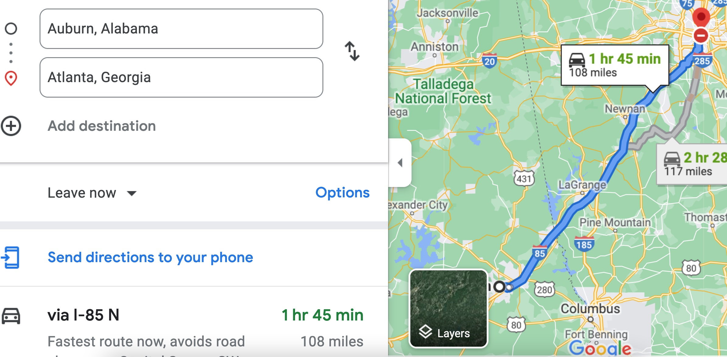

Therefore, the time t = 108 miles/60mph * 60 minutes/hour= 108 minutes. Since John left at 8am, he will then reach Atlanta at 8am + 108 minutes = 8 am + 60 minutes + 48 minutes = 9:48".

**Student 3** will get 25 + 15 + 60 = 100 points

Do you see the **direct** **link** going from the data provided in the question to the final answer, using general knowledge/formula and documents?.... Can you now solve the following problem and get 100 points?

"(100 points) Alice travels from Auburn to Atlanta in her car at a speed of 60 mph. Leaving at 8am, at what time will Alice reach Atlanta assuming that she had a flat tire that delayed her 30 minutes".

1. See **Appendix** about what an obvious and clear link is.